YOLOv8-Based River Debris Monitoring System With Meteorological Data for Flood Mitigation
Kelvin Alexander Harli
Information Systems Department
School of Information Systems
Bina Nusantara University
Jakarta, Indonesia 11480
kelvin.harli@binus.ac.id
Ferdy Saputra
Information Systems Department
School of Information Systems
Bina Nusantara University
Jakarta, Indonesia 11480
ferdy.saputra@binus.ac.id
Edi Purnomo Putra
Information Systems Department
School of Information Systems
Bina Nusantara University
Jakarta, Indonesia 11480
eputra@binus.edu

Abstract— Urban flooding remains one of the most frequent hydrometeorological disasters in Indonesia. This situation is usually triggered by heavy rains and the accumulation of floating debris that can obstruct the flow of the river. However, many current flood monitoring systems still rely on only one type of hydrological data and therefore cannot fully describe conditions on the ground. This study proposes a flood potential monitoring system that integrates precipitation data and river debris detection using deep learning. The YOLOv8 model was trained using a custom dataset of 2,249 images to detect debris on the river surface. Next, the detection results are integrated with rainfall data from BMKG using the Simple Additive Weighting (SAW) method to determine the flood risk level. The test results demonstrate that the model is able to detect debris effectively in complex aquatic environments, with a precision of 0.788, a recall of 0.773, an mAP50 of 0.789, and an mAP50-95 of 0.445. The integration of visual and meteorological data applied in this study can provide more complete information to support early flood warning systems. In addition, the integrated control panel developed provides a visualization tool that allows monitoring of potential flooding by integrating debris detection and rainfall data.
Keywords—yolov8, flood monitoring, debris detection, deep learning

Introduction
One of the most common hydrometeorological catastrophes in Indonesia is still flooding, which is mostly caused by high rainfall and growing changes in land usage. In 2025, 2.009 flood incidents were reported across Indonesia, indicating that flooding is one of the most frequent hydrometeorological disasters in the country. This case shows that flooding is still a major issue that needs to be given more consideration in catastrophe risk reduction and management initiatives.
Heavy rainfall, the topography of the region, changes in land use, urbanisation along riverbanks, and the buildup of trash that blocks airflow are just a few of the interconnected elements that may create floods [1].
Debris or trash obstructing river flow, which lowers the riverbed's capacity, particularly during periods of high rainfall, is one of the primary causes of floods [2]. Plastic garbage, timber, branches, and other floating debris may obstruct a river's flow and raise the possibility of flooding [3], [4].
Several previous studies have examined river condition monitoring and debris detection in aquatic environments to support flood mitigation. Z. Huangfu et al. (2024) developed Ghost-YOLOv8 for the detection of floating debris [5]. A. Pierret et al. (2025) proposed a river water level monitoring system based on ToF sensors [6]. P. Luadnakrob et al. (2026) analyzed the movement of floating plastic debris in aquatic environments [7]. B. Badams et al. (2026) developed A2ANet to improve debris detection performance in various complex water conditions [8].
However, most previous studies still focus on a single approach, either through hydrological parameters or visual analysis. In fact, flood potential is influenced by various factors, so the integration of several indicators is important. To date, the integration of visual indicators, such as debris density, with precipitation data has been little studied.
Based on these limitations, this study proposes a flood potential monitoring system that integrates deep learning-based debris detection with precipitation data. Images of the river surface were analyzed using the YOLOv8 algorithm to detect and calculate debris density, and then combined with precipitation data from the API BMKG to produce a dashboard-based flood monitoring system.
This study also proposes a method for estimating debris density by considering the river's cross-sectional area, in order to improve the accuracy of the analysis. This approach allows for a more representative estimate of water flow conditions and has been tested through a real-world case study.
The novelty of this study lies in the development of a flood potential monitoring system that combines debris detection using YOLOv8 with precipitation data from the BMKG. Unlike previous studies that focused solely on debris detection or hydrological monitoring, this study integrates debris density and precipitation using the SAW method to generate flood potential indicators. The integrated model is implemented on a monitoring control panel to facilitate the practical implementation of the system. The control panel presents the results of the debris detection analysis and rainfall data as supplementary information for monitoring potential flooding.
The proposed research questions are as follows:
1) How can the YOLOv8 algorithm be used to detect debris floating on the surface of a river?
2) How can the use of a debris density method based on the cross-sectional area of ​​the river improve the representation of water flow conditions?
3) How can the integration of debris density and rainfall data be used to produce more accurate indicators of flood potential?
The main contributions of this study are the following:
1) To propose a method for detecting floating debris using the YOLOv8 algorithm based on deep learning.
2) Reveal the debris density method considering the river's cross-sectional area as a contextual variable.
3) Integrate debris density, river cross-sectional area, and precipitation data to generate a multiparametric indicator of flood potential.
This study is structured as follows: Section II analyzes research related to flood monitoring and object detection using deep learning. Section III describes the research methodology and the architecture of the proposed system. Section IV presents the experimental results and an analysis of the developed system. Finally, Section V presents the study's conclusions and future research directions.

Literature Review
Urban flooding occurs due to various interconnected factors, such as heavy rainfall, insufficient drainage capacity, and the accumulation of debris in river channels, which can obstruct the flow of water [9], [10]. This situation is particularly relevant in coastal cities with high rates of urbanization, such as Semarang. The physical condition of watercourses can also influence local hydrology. Consequently, assessing flood risk requires information on both meteorological conditions and the current state of the rivers.
Flood monitoring methods have evolved from direct field observations to the use of sensors, IoT, and predictive models [11], [12]. Artificial intelligence and machine learning can help monitoring systems analyze environmental data under constantly changing conditions [13]. However, many existing approaches still rely on precipitation or water level measurements. Although these parameters provide important hydrological information, they do not directly describe visual conditions within the river channel. Table I presents previous studies and highlights the research gaps addressed in this study.
- Review of Related Research and Research Gaps
Ref | Model | Findings | Research Gap
[5] | Ghost-YOLOv8 | It generates a lighter, more accurate, and more efficient floating debris detection model for real-time monitoring | Focus on debris detection without flood potential analysis
[6] | ToF Sensor | Capable of automatically and continuously monitoring river water levels with good accuracy | Does not integrate visual debris analysis
[7] | PTM | It shows the movement and distribution patterns of floating plastic debris in aquatic environments | Does not provide flood monitoring system
[8] | A2ANet | Improve the accuracy and robustness of debris detection in various complex aquatic environmental conditions | Not yet integrated meteorological data and multi parameter based flood potential analysis
Flood monitoring remains a challenge, as it still relies on direct human observation in many areas [14]. Computer vision offers an alternative by enabling the analysis of river conditions using visual data [15]. Among the various object detection methods available, YOLO is widely used due to its rapid detection capability and relatively low computational requirements [16]. The results of image-based monitoring continue to be affected by environmental conditions such as rain, fog, and poor visibility factors that can degrade image quality and hinder the detection of floating objects [17]. Previous research has demonstrated that YOLOv8 can achieve effective detection performance with a dataset of approximately 500 to 1,000 images when the mosaic data augmentation technique is applied [18]. Furthermore, meteorological data are also frequently used in flood forecasting, as they can provide an overview of atmospheric conditions. On the other hand, meteorological data, as a representation of atmospheric conditions, are often used to support flood predictions, as they provide an overview. However, the high climate variability in tropical regions makes predictions less stable if they are not combined with actual conditions on the ground [19]. Therefore, an approach based solely on one type of data, whether visual or meteorological, has not yielded optimal results in a flood monitoring system.
This study addresses this deficiency by integrating computer vision-based video analysis, YOLO object detection, and meteorological data as a hydrometeorological variable into a single flood monitoring system. Unlike previous studies that tend to use a single approach. This study combines visual detection results with meteorological data through the Simple Additive Weighting (SAW) method [20]. The main contribution of this research is the development of a monitoring system that integrates visual information on river conditions and meteorological data into the flood risk assessment process. Both types of information are used to determine the level of flood risk in urban river areas.

Method

Research Approach
This study combines YOLOv8-based debris detection with BMKG precipitation data to assess flood potential. The system was implemented and evaluated using observations from the Ciliwung River near Manggarai Station. The assessment results were generated using the Simple Additive Weighting (SAW) method.

Research Flow
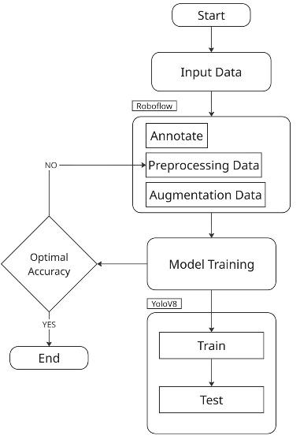
Fig. 1. Model methodology [21]
Fig. 1 illustrates the overall workflow of the proposed system. River images are first prepared and used to train the YOLOv8 model for debris detection. After training and evaluation, the model identifies floating debris and calculates its density. The resulting debris information is then combined with precipitation data using the SAW method to generate a flood potential score

Data Acquisition and Preparation
The dataset consisted of original photographs and open-source images from Roboflow Universe, including Meehirs Workspace, Trash SJ, and Object Detection Debris, totaling 2,249 images. Each debris object was annotated with a bounding box and converted into the YOLOv8 format.
Before being used in the training process, the data undergoes a preprocessing stage that includes data cleaning, image resizing, and pixel value normalization. To enrich data diversity and reduce the risk of overfitting, spatial and photometric augmentations were performed, including brightness adjustments, random rotation, and horizontal flipping of the images.

YOLOv8 Model Training and Testing
After preprocessing, the images were prepared in the YOLO annotation format and randomly divided into training, validation, and test sets. Model training was conducted using Google Colab, with transfer learning applied from pre-trained COCO weights to improve training efficiency. The trained model was subsequently evaluated using unseen test data that had not been included during training. Detection performance was assessed using confidence scores and mean average precision (mAP) to evaluate the accuracy and reliability of the system [23].

Flood Potential Assessment Using SAW
The debris detection results obtained using YOLOv8, combined with precipitation data from the BMKG API, are used to estimate flood potential via the Simple Additive Weighting (SAW) method. The assessment is based on two criteria: debris density (C1), with a weighting of 0.40, and precipitation intensity (C2), with a weighting of 0.60. A higher weighting was assigned to precipitation because this factor is directly related to an increased risk of flooding [22]. Furthermore, the density of the debris is used to indicate the possible presence of obstructions that could impede the smooth flow of the river. Both criteria were then normalized and aggregated to produce a single flood potential score.
Estimating river cross-sectional conditions from monocular CCTV images presents geographical and spatial limitations. To address this issue, the study applied a hybrid static-dynamic approach. The dynamic observation area was calibrated according to the dimensions of the CCTV camera frame, while the river depth profile was obtained from historical literature. The detected debris pixel density was then compared with this depth profile to estimate the remaining flow capacity of the river.
$$\begin{aligned}\text{S }\text{= }\left({\text{R}}_{\text{1}}\text{×0.40}\right)\text{+ }\left({\text{R}}_{\text{2}}\text{×0.60}\right)\#\left(1\right)\end{aligned}$$
The flood potential status is determined based on the following Table II.
- SAW Score Classification
SAW Score | Status
S ≥ 0.70 | FLOOD DANGER
0.40 ≤ S < 0.70 | FLOOD WARNING
S < 0.40 | SAFE
Actual flood conditions observed in the river were used as the reference for evaluating the forecasting system. Ground-truth information was obtained from visual observations of river videos and synchronized with meteorological data based on their timestamps. The model's predictions were then evaluated across three risk categories: SAFE, FLOOD WARNING, and FLOOD DANGER.
- Results And Discussion

Hardware and Equipment
The system was developed and validated using a workstation equipped with an Intel Core i5-11400H processor, 16 GB of RAM, and Windows 11. A cloud-based platform was also used to support the computational requirements of model training. Combining local and cloud computing resources helped maintain system stability and improve processing efficiency.

Performance Metrics
Specially, the overall performance is measured using Mean Average precision (mAP) as the primary benchmarking across all classes. Accuracy measure the model precision exactness of the predicted bounding boxes, where recall shows how good the system is at finding all the actual targets in the image. Furthermore, f1-score assesses the trade of between exactness and target recovery, where mAP provide a comprehensive overview of the model performance in object detection and classification.
The formulas for precision and recall are defined as follows:
$$\begin{aligned}\text{Precision}\text{ =}\frac{\text{TP}}{\text{(}\text{TP}\text{+}\text{FP}\text{)}}\#\left(2\right)\end{aligned}$$
$$\begin{aligned}\text{Recall}\text{=}\frac{\text{TP}}{\text{TP+FN}}\#\left(3\right)\end{aligned}$$
Where TP (true positive) number of correct predictions, FN (False Negative) number of detection object.
The F1 score is the harmonic mean of precision and recall, which is formulated as follows:
$$\begin{aligned}\text{F1}\text{=2}\text{⋅}\frac{\text{Precision}\text{⋅}\text{Recall}}{\text{Precision+Recall}}\#\left(4\right)\end{aligned}$$
Additionally, mean average precision (mAP) used as the primary metric, showing object detection performance and value is for mAP is obtained from the average precision (AP).
Across all class, which is calculate base on the relationship between prevision and completeness.
$$\begin{aligned}\text{mAP}\text{=}\frac{1}{N}\sum_{\text{i=1}}^{\text{N}}{\text{A}{\text{P}}_{\text{i}}}\#\left(5\right)\end{aligned}$$
Model errors can be observed in the confusion matrix to identify which classes were most frequently affected by prediction errors. During the training process, model performance is also monitored using values for bounding box loss, classification loss, and Distribution Focal Loss (DFL). The lower the values of these three metrics, the better the model's ability to accurately locate and recognize objects.

Training Analysis of YOLOv8
Fig. 2 shows the changes in box_loss, cls_loss, and dfl_loss over 150 training epochs. Precision, recall, and mAP complement these loss metrics to monitor model performance during the training process. The box loss decreased from 1.50 to 0.50, showing that the model became better at locating objects. The Dfl_loss also decreased from 1.19 to 0.83, reflecting an improvement in the bounding box regression process. Overall, the downward trend in the loss metrics, together with the precision, recall, and mAP results, indicates that the model's performance in recognizing, localizing, and classifying riverine waste improved as the number of training epochs increased.
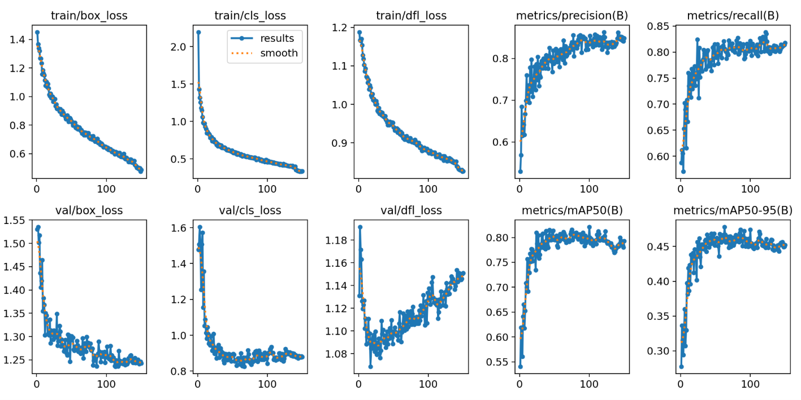
Fig. 2. YOLOv8 result

Evaluation Results
After completing the training and validation stages, the YOLOv8 model was evaluated using unseen data. Fig. 3 shows several examples of floating riverine debris detection results under various conditions. The model is capable of recognizing various types of waste simultaneously, with plastic being the most frequently detected object. The resulting bounding boxes also generally correspond to the actual positions of each object. Furthermore, when several debris fragments are located very close to one another within the same frame, the model remains capable of distinguishing and recognizing the objects individually.
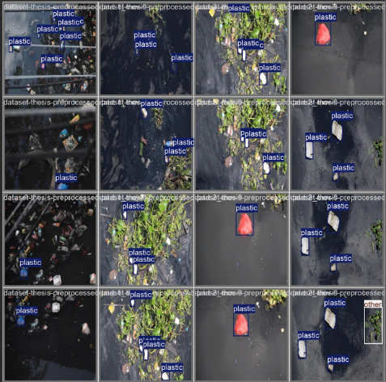
Fig. 3. Object detection results using the YOLOv8 model
The model achieved a precision of 0.788, a recall of 0.773, an mAP50 of 0.789, and an mAP50-95 of 0.445. According to the evaluation results, the wood class showed the best performance, with a precision of 0.804 and an mAP50 of 0.926. The paper class also yielded favorable results, with a precision of 0.876 and an mAP50 of 0.800. On the other hand, the other class exhibits the lowest performance, with a recall of 0.683 and an mAP50 of 0.645. This result is likely influenced by the diversity of objects within the category, which makes it difficult for the model to learn coherent visual patterns.
The model's detection performance is also influenced by environmental conditions in the river setting; for instance, changes in light intensity and reflections on the water's surface can hinder the visibility of floating debris, potentially reducing detection accuracy. However, this condition does not completely limit the capabilities of the YOLOv8 model. Despite some residual classification errors, the model generally remains capable of locating the main categories of riverine waste. Most of the objects were correctly identified, although some appeared indistinct due to glare or changing lighting conditions on the water's surface.
- Result of the Yolov8 Model Performance Evaluation
Class | Img | Ins | P | R | mAP50 | mAP50-95
All | 283 | 702 | 0.788 | 0.773 | 0.789 | 0.445
Bottle | 27 | 46 | 0.715 | 0.761 | 0.751 | 0.263
Other | 59 | 142 | 0.751 | 0.683 | 0.645 | 0.385
Paper | 38 | 95 | 0.876 | 0.705 | 0.800 | 0.381
Plastic | 135 | 394 | 0.793 | 0.797 | 0.821 | 0.496
Wood | 24 | 25 | 0.804 | 0.920 | 0.926 | 0.701
Img. = Images, Inst. = Instances, P = Precision, R = Recall
Fig. 4 shows that the majority of objects were correctly identified, with plastic showing the highest number of correct detections, and bottles and paper also performing well with relatively few errors. The other class was more prone to errors, as the objects assigned to it often share visual similarities with items from other categories, making them harder to distinguish. This class was deliberately maintained as a catch-all category for waste outside the four main categories, so that estimating debris density across five classes would not result in greater imbalance through further subdivision. Some objects were also missed against the background due to inadequate positioning or lighting. Despite these occasional errors, the confusion matrix generally indicates solid classification performance. Localization was somewhat weaker under stricter IoU thresholds, reflected in the lower mAP50-95 (0.445), a common result in floating object detection, where debris often occupies only a small area of ​​the frame, making it difficult to obtain precise bounding boxes.[23].
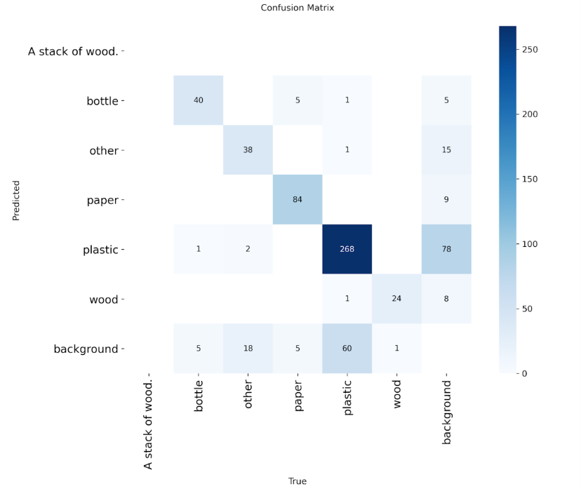
Fig. 4. Confusion matrix of the YOLOv8 model evaluation results

Discussion
The model's effectiveness in supporting flood risk monitoring was evaluated by comparing its performance with the results of previous studies. Evaluation is carried out by considering prediction accuracy and inference speed. Both aspects are important because the monitoring system must generate information quickly to enable a more agile response. The results of comparing the model's performance with previous studies are presented in Table IV.
- Yolov8 Performance Comparison
Model Architecture | Paradigm / Key Feature | mAP50 | Inference Speed (FPS) | Reference
YOLOv7 | Baseline Single Stage | 0.800 | 179 | [24]
YOLOv7 + CBAM | Attention Augmented | 0.901 | 49.5 | [25]
YOLOv8-SST | Small Target Optimization | 0.912 | 86 | [26]
A2ANet | Attention to Attention | 0.841 | 26 | [8]
Proposed YOLOv8 | Optimized Baseline for EWS | 0.789 | 89.3 | Proposed Study
The YOLOv8-SST had the greatest mAP50 value, 0.912, according to the assessment findings, with an inference speed of around 86 FPS. In contrast, the proposed YOLOv8 model achieved an end-to-end processing speed of approximately 89.3 FPS with an mAP50 of 0.789.
Flood potential is calculated using the simple additive weighting (SAW) method, which combines debris density and precipitation. A weight of 0.40 is assigned to debris density, while rainfall receives a weight of 0.60 because it plays a more significant role in triggering floods. The reason the SAW method was chosen was because it is computationally efficient and is able to combine several parameters into a single evaluation index.
The amount of rainfall and the density of debris clearly influence the classification results produced by the system. In most test data, conditions with higher rainfall and greater debris accumulation tend to result in a state of FLOOD RISK, while lower values ​​are generally classified as SAFE. The classification results obtained from the combination of YOLOv8 and the SAW method also showed conformity with the river conditions observed during the tests.

Validation of SAW Flood Classification
The SAW classification was evaluated using 36 pre-labeled samples: 20 SAFE, 5 FLOOD WARNING, and 11 FLOOD DANGER. As presented in Table V, the model achieved an accuracy of 0.5556, precision of 0.1852, recall of 0.3333, and F1 score of 0.2381. As shown in Fig. 5, all samples were classified as SAFE, indicating that the current weighting scheme of 0.60 for precipitation and 0.40 for debris density underestimates flood risk. Therefore, the weightings and decision thresholds require recalibration.
- Flood Risk Classification Metrics
Metric | Value
Accuracy | 0.5556
Precision | 0.1852
Recall | 0.3333
F1-Score | 0.2381
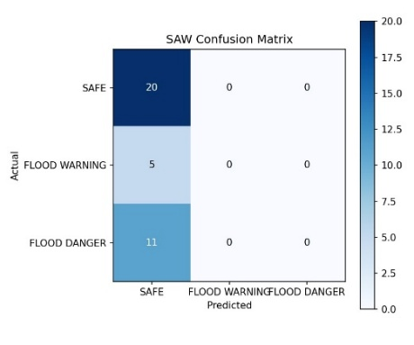
Fig. 5. SAW Confusion Matrix

Theory Implication
This study contributes to flood monitoring research by combining YOLOv8-based river debris detection with the Simple Additive Weighting (SAW) method in a multi-criteria decision-making framework. This approach extends conventional single-parameter monitoring by considering both the physical condition of the river and meteorological factors associated with urban flooding.

Practical Implication
This system allows for remote monitoring of river conditions, without the need for frequent site visits. River images are processed to generate information on the presence of waste and subsequently integrated with meteorological data on a single platform, allowing the monitoring results to provide a more comprehensive view of river conditions. Concise information can help disaster response teams identify areas at highest risk of flooding and prepare cleanup activities before heavy rains occur. Preventive measures can also be adopted at an earlier stage to help curb the risk of flooding.

Limitation
This study still presents several limitations that should be taken into account. The analysis employed has not yet incorporated river water levels or flow velocities as evaluation variables; consequently, it is not yet possible to fully characterize the state of the river. Detection accuracy may also vary due to environmental conditions, such as poor lighting and limited visibility. Roboflow sources, meaning that the model's capabilities have not yet been exhaustively tested under conditions such as nighttime, heavy rain, or new river environments with different characteristics. BMKG precipitation data are not yet available in real-time. Furthermore, the SAW method currently employs fixed weights, which could be adjusted in future research to improve the accuracy of flood risk assessment.

Conclusions
This study successfully developed a river monitoring system that integrates debris detection using YOLOv8, debris density estimation, and precipitation data for flood potential analysis. Test results showed that the model achieved a precision of 0.788, a recall of 0.773, and an mAP50 of 0.789. Integrating debris density and precipitation generated a more comprehensive flood potential indicator and facilitated river monitoring through a dashboard.
Furthermore, river cross-sectional capacity is still estimated using static depth profiles and camera pixel calibration; consequently, it is not yet possible to represent changes in river morphology. Budgetary and time constraints also hinder the implementation of IoT sensors. It is recommended that future research integrate IoT sensors, additional hydrological parameters, and adaptive methods, and evaluate the sensitivity of SAW weightings and classification results against actual flood data, in order to improve the reliability of the risk assessment.

Author Contribution Statement
K. A. Harli: responsible for the literature review, manuscript drafting and editing, and article formatting. F. Saputra: responsible for technical experiments, dataset management YOLOv8 development, mAP evaluation, SAW implementation, CCTV integration, and system validation. E. P. Putra: provided supervision, methodological guidance, and evaluation of the research results and manuscript.

Acknowledge
We gratefully acknowledge the Research and Technology Transfer Office (RTTO) of BINUS University for providing financial support for this research. The dataset utilized in this research has been publicly released and is available through the Zenodo repository at https://doi.org/10.5281/zenodo.20413204.

References
[1] H. R. Haezer, H. Herawati, and Nurhayati, “Analisis faktor-faktor penyebab banjir pada bagian hilir das sekadau,” JeLAST J. Tek. Kelautan, PWK, Sipil, dan Tambang, vol. 11, no. 2, pp. 1–6, 2024.
[2] N. N. F. Hakim et al., “Pendampingan masyarakat dalam identifikasi faktor lingkungan penyebab banjir di jalan senopati raya kota bandar lampung,” J. Pengabdi. Masy. Bhinneka, vol. 3, no. 4, pp. 390–399, 2025, doi: 10.58266/jpmb.v3i4.172.
[3] D. Romano, C. Mennella, and M. Lapegna, “A deep learning-based method for efficient floating garbage debris recognition on high-performance edge computing platform,” Futur. Gener. Comput. Syst., vol. 174, no. April 2025, p. 108000, 2026, doi: 10.1016/j.future.2025.108000.
[4] A. Nggilu, N. Raffi Arrazaq, and T. Thayban, “Dampak pembuangan sampah di sungai terhadap lingkungan dan masyarakat desa karya baru,” Normalita, vol. 10, pp. 196–202, 2022.
[5] Z. Huangfu, S. Li, and L. Yan, “Ghost-YOLO v8: an attention-guided enhanced small target detection algorithm for floating litter on water surfaces,” Comput. Mater. Contin., vol. 80, no. 3, pp. 3713–3731, 2024, doi: 10.32604/cmc.2024.054188.
[6] A. Pierret, N. Silvera, K. O. Latsachack, K. Chanthavong, P. Sounyafong, and O. Ribolzi, “A float-controlled self-contained laser gauge for monitoring river levels in tropical environments,” HardwareX, vol. 23, no. April, 2025, doi: 10.1016/j.ohx.2025.e00682.
[7] P. Luadnakrob et al., “A numerical model approach on floating riverine plastic debris with wind-induced re-drifting process from beaches along the Gulf of Thailand,” Reg. Stud. Mar. Sci., vol. 93, no. December 2025, 2026, doi: 10.1016/j.rsma.2025.104718.
[8] B. Badams et al., “A2ANet: Real-time detection of floating marine debris using atrous convolution and channel attention,” Ecol. Inform., vol. 94, no. January, p. 103620, 2026, doi: 10.1016/j.ecoinf.2026.103620.
[9] A. Stephen, R. Kimwaga, D. M. M. Mulungu, and F. J. Izdori, “Environmental and Sustainability Indicators Flash flood risk assessment and sanitation infrastructure vulnerability in unplanned urban areas : A GIS-based analysis of the Sinza River catchment , Dar es Salaam,” Environ. Sustain. Indic., vol. 30, no. January, p. 101170, 2026, doi: 10.1016/j.indic.2026.101170.
[10] L. Mdegela, Y. De Bock, E. Luhanga, J. Leo, and E. Mannens, “Monitoring Kikuletwa river levels in northern Tanzania : A data set unlocking insights for effective flood early warning systems,” Data Br., vol. 49, p. 109395, 2023, doi: 10.1016/j.dib.2023.109395.
[11] M. Izzat, W. A. Jabbar, and N. Sulaiman, “Internet of things and cyber-physical systems development of a smart sensing unit for LoRaWAN-based IoT flood monitoring and warning system in catchment areas,” Internet Things Cyber-Physical Syst., vol. 3, pp. 249–261, 2023, doi: 10.1016/j.iotcps.2023.04.005.
[12] P. M. Nasiya and M. Prathilothamai, “Long -term prediction of floods with a TSVD-LSTM based on the century-scale rainfall data: A case study on Kerala, India.,” Prog. Disaster Sci., p. 100584, 2026, doi: 10.1016/j.pdisas.2026.100584.
[13] R. Sajja, S. Xiong, O. Mermer, Y. Sermet, and I. Demir, “A bibliometric overview of conversational AI in hydrology and environmental sciences,” Inf. Geogr., vol. 1, no. 2, p. 100030, 2025, doi: 10.1016/j.infgeo.2025.100030.
[14] M. Bagus, A. Rianto, and F. Afif, “Design of automatic flood control system in kulon progo , special region of yogyakarta , indonesia,” Results Eng., vol. 23, no. May, p. 102620, 2024, doi: 10.1016/j.rineng.2024.102620.
[15] H. Adikari, “Computer vision in flash flood forecasting : A narrative review of applications , integration pathways , and future directions,” Environ. Model. Softw., vol. 198, no. October 2025, p. 106910, 2026, doi: 10.1016/j.envsoft.2026.106910.
[16] W. Dai, Z. Zhang, Z. Zhang, and H. Zhu, “YOLOv8-GSC : an agricultural crop precision detection model integrating lightweight network and attention mechanism,” Alexandria Eng. J., vol. 145, no. April, pp. 63–76, 2026, doi: 10.1016/j.aej.2026.04.027.
[17] A. Diva, P. Putri, C. Agustine, S. Hartono, I. Val, and D. Reyes, “SiPadi : an android-based rice disease detection application using YOLOv8 with CPMAI methodology – a case study in kandri village,” Procedia Comput. Sci., vol. 269, pp. 1161–1170, 2025, doi: 10.1016/j.procs.2025.09.057.
[18] I. Apeināns, “Optimal size of agricultural dataset for yolov8 training,” vol. 2, pp. 38–42, 2024.
[19] R. Ramadhan, M. Marzuki, W. Suryanto, and S. Sholihun, “Rainfall variability in Indonesia new capital associated with the Madden-Julian Oscillation and its contribution to flood events,” Quat. Sci. Adv., vol. 13, no. June 2023, p. 100163, 2024, doi: 10.1016/j.qsa.2024.100163.
[20] R. A. Ribeiro, L. M. Camarinha-matos, N. Vafaei, R. A. Ribeiro, and L. M. Camarinha-matos, “Assessing normalization techniques for simple additive weighting method,” Procedia Comput. Sci., vol. 199, pp. 1229–1236, 2022, doi: 10.1016/j.procs.2022.01.156.
[21] A. Arishi, “Real-time household waste detection and classification for sustainable recycling: a deep learning approach,” Sustain., vol. 17, no. 5, 2025, doi: 10.3390/su17051902.
[22] M. Al Kuisi, N. Al Azzam, T. Hyarat, and I. Farhan, “Flood Hazard and Risk Assessment of Flash Floods for Petra Catchment Area Using Hydrological and Analytical Hierarchy (AHP) Modeling,” Water (Switzerland), vol. 16, no. 16, 2024, doi: 10.3390/w16162283.
[23] L. Song, H. Deng, J. Han, and X. Gao, “Improved Aerial Surface Floating Object Detection and Classification Recognition Algorithm Based on YOLOv8n,” Sensors, vol. 25, no. 6, 2025, doi: 10.3390/s25061938.
[24] C. Peng, B. He, W. Xi, and G. Lin, “Improved yolov7 algorithm for floating waste detection based on gfpn and long-range attention mechanism,” Wuhan Univ. J. Nat. Sci., vol. 29, no. 4, pp. 338–348, 2024, doi: 10.1051/wujns/2024294338.
[25] J. Wang, J. Wu, J. Wu, J. Wang, and J. Wang, “YOLOv7 optimization model based on attention mechanism applied in dense scenes,” Appl. Sci., vol. 13, no. 16, 2023, doi: 10.3390/app13169173.
[26] H. Dong, “Improved YOLOv8-SST for accurate detection of small floating objects in complex water environments,” pp. 1–22, 2026,

